Managing Your Employee Profile in SuccessFactors Quick Reference Guide
Last Updated: 09/08/2023

This guide outlines the primary tasks employees might complete within their Employee Profile in SuccessFactors. Additional resources and documentation can be found on the SuccessFactors Training Resources Page, found at SuccessFactors Training Resources - Human Resources - Purdue University
Contents
Accessing SuccessFactors 1
Viewing Your Pay Statement 1
Recording Time - Positive Duration or Negative Duration 1
Recording Time - Webclock 2
Requesting Time Off 2
Editing Personal Information 4
Editing Bank Information 4
Editing Tax Information 4

Accessing SuccessFactors
- Use an internet browser to visit the OneCampus Portal (https://one.purdue.edu/).
- Click Employee Launchpad
- Log in with Username and Password

Viewing Your Pay Statement
Scroll down to the Organizational Updates – Additional Actions section  Click Pay Statements |  |  | 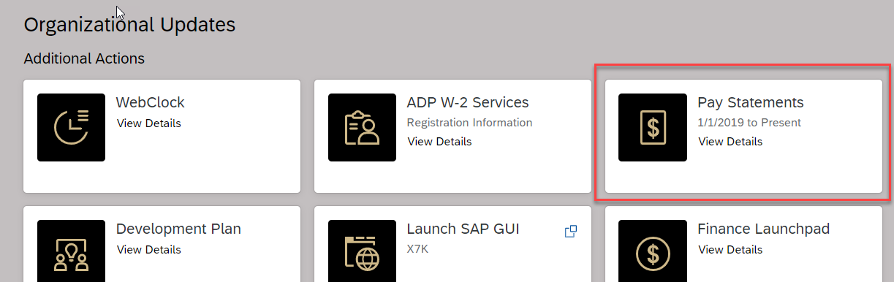

Recording Time - Positive Duration or Negative Duration
This section applies to individuals who utilize Positive Duration Entry or Negative Duration Entry timekeeping. For detailed resources and instructions for time entry.
If you hold multiple positions, use the Change Selected Employment menu to select the position for which you would like to record time | 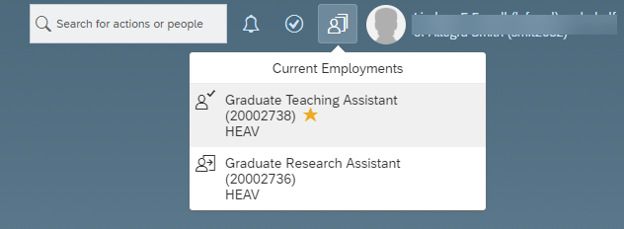
If you hold multiple positions and they are similarly named, click My Profile to validate that the correct position has been selected | 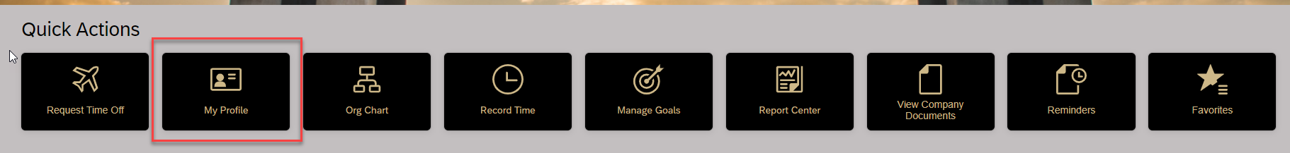
If you hold multiple positions and they are similarly named, click the Employment Information tab to view the details of the position selected in order to ensure time is recorded for the correct position. | 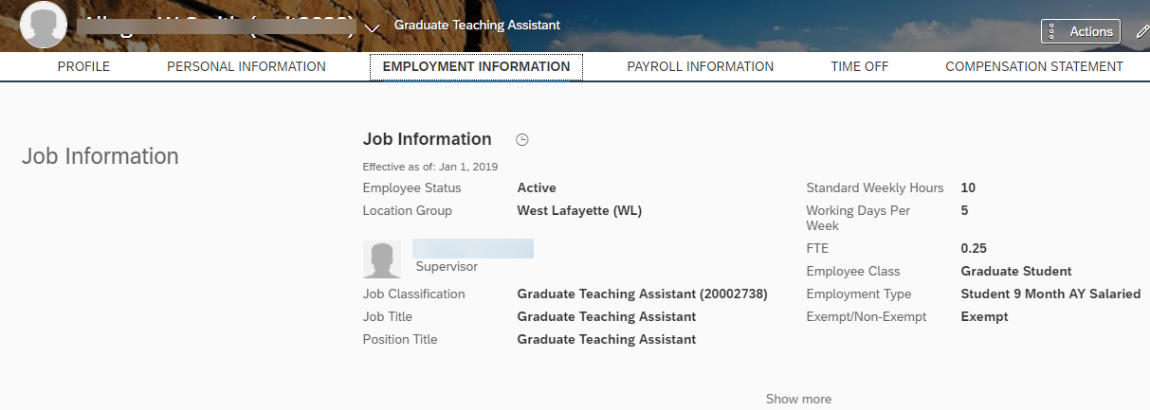
(If you completed the previous steps to verify multiple positions, return to the SuccessFactors home page and select the desired position).

Click My Time Sheet under Quick Actions

Requesting Time Off
Detailed resources and documentation SuccessFactors Training Resources - Human Resources - Purdue University
If you hold multiple positions, use the Change Selected Employment menu to select the position for which you would like to record time
If you hold multiple positions and they are similarly named, click My Profile to validate that the correct position has been selected
If you hold multiple positions and they are similarly named, click the Employment Information tab to view the details of the position selected in order to ensure time off is requested for the correct position.
(If you completed the previous steps to verify multiple positions, return to the SuccessFactors home page and select the desired position). Click the Request Time Off tile. |  | 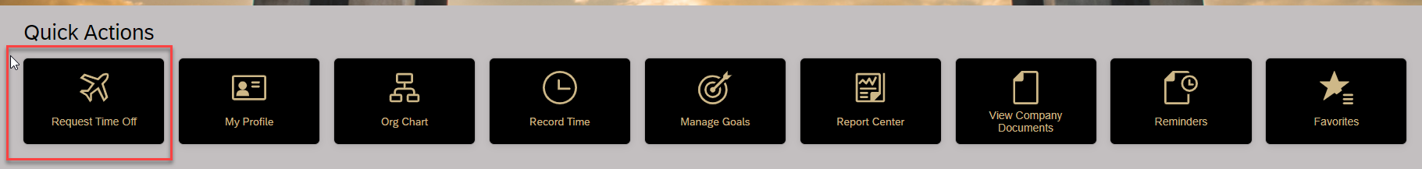
- Click the type of leave being requested, or select it from the Time Type field  - Select from the calendar or enter the date(s) being requested in the Start Date and End Date fields  - In the Requesting field, select or enter the amount of time being requested  - Optional: Enter a comment for your supervisor  - Click Submit.  Please note – to view account balances, absences and calendar view, click Time Off link. |  | 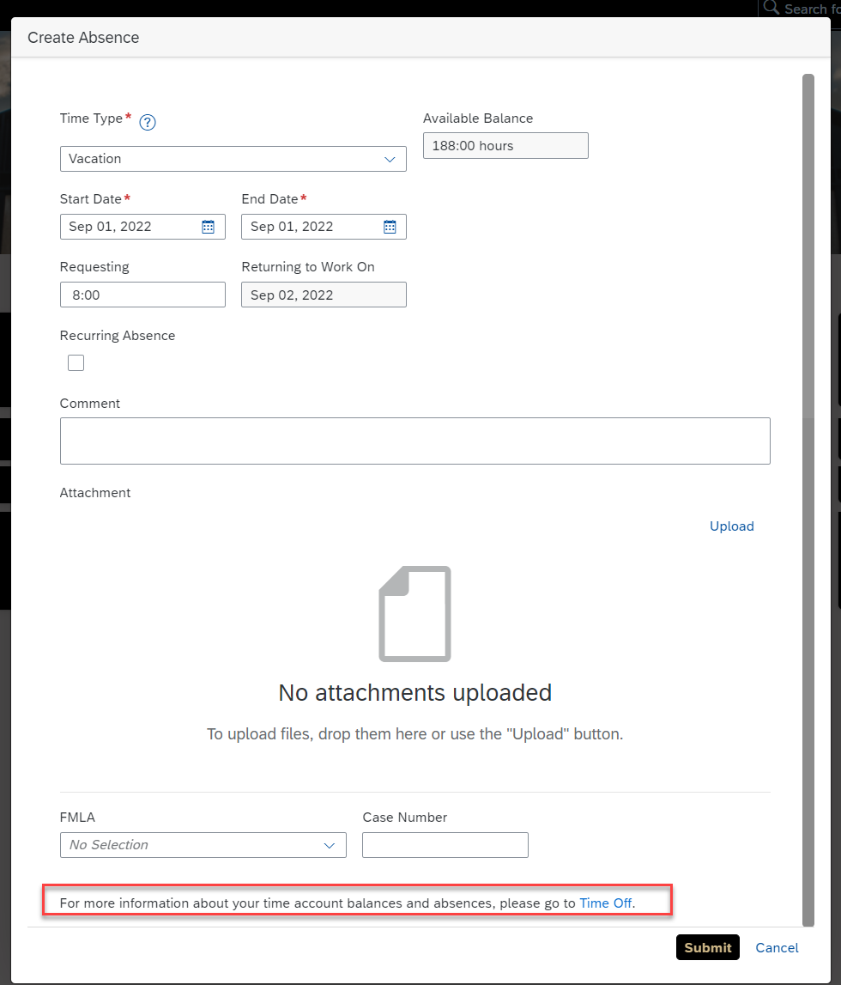

Editing Personal Information
Click the My Profile tile |  |  | 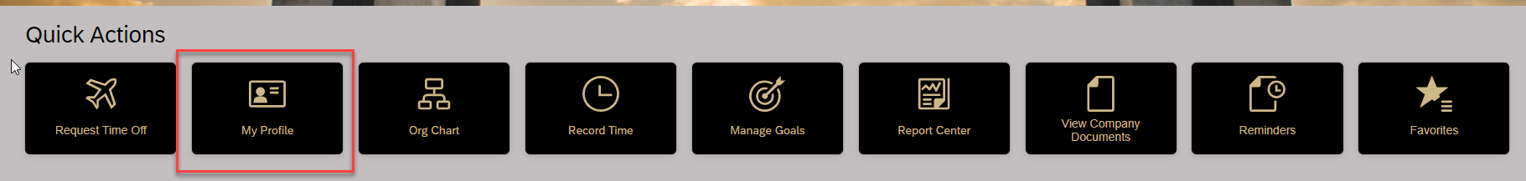
Click the PERSONAL INFORMATION tab |  |  | 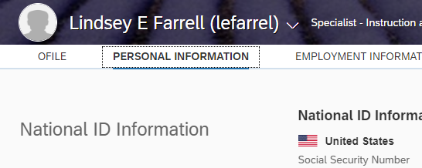
Only the following information is editable. Contact your business office / center to edit other information.  - Home Address  - Home Phone Number  - Emergency Contact  Click Edit (the pencil icon ) to edit the fields. |  |  | 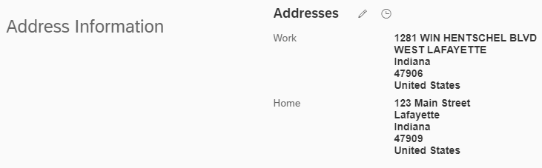

Editing Bank Information
Click the Payroll tab and then Bank ESS |  |  | 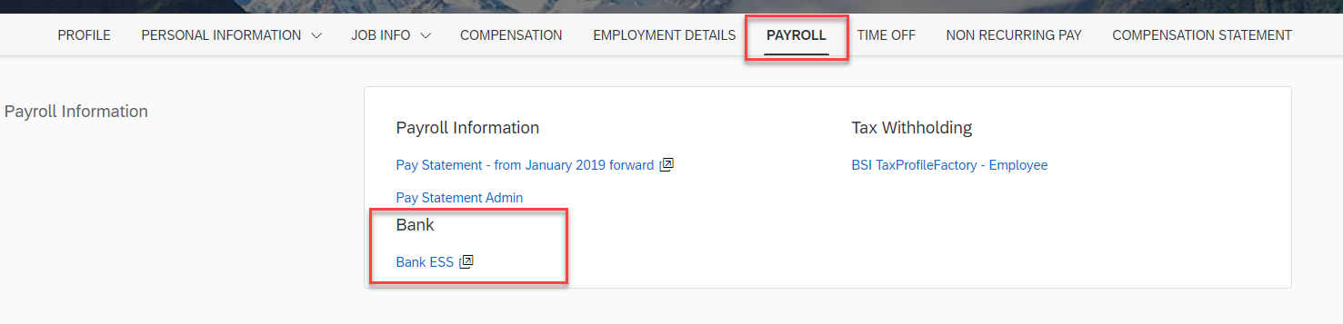
Click Edit (the Pencil icon) to edit bank info.  Click Other bank to add new bank. |  |  | 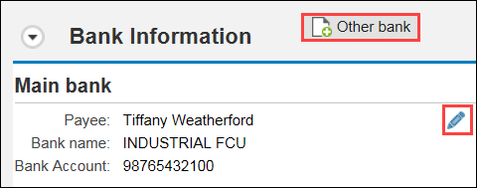  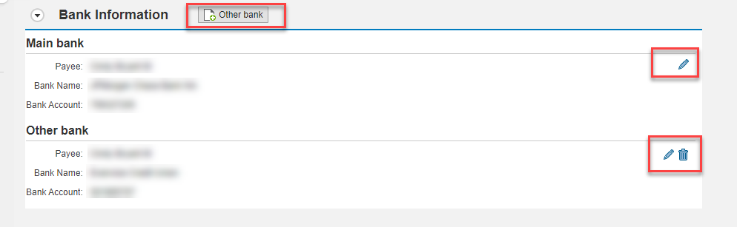

Editing Tax Information
While still under Payroll -  Click BSI TaxProfileFactory – Employee  Click View/Change Completed Forms | 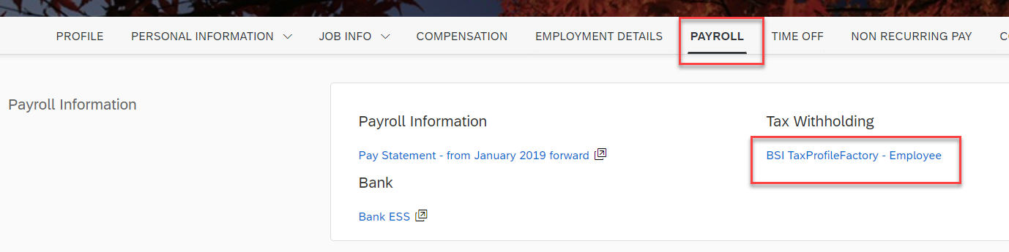  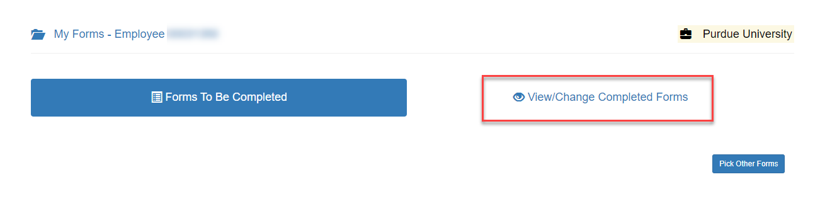
Make any necessary adjustments and submit. | 